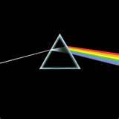The Dark Side of the Jung 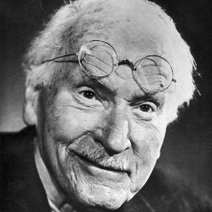
Using the Wizard of Oz to instruct Carl Jung, the Collective Unconscious, Archetypes, Apophenia and Subjective Validation
Dark Side of the Moon, probably the second greatest album of all-time or tied for first with The Who’s By the Numbers, has long been rumored to provide a soundtrack for the classic film Wizard of Oz.
Step 1: Get a DVD of Wizard of Oz and a Pink Floyd’s Dark side of the Moon. (YOU CAN USE YOUTUBE NOW-SOME AWESOME PERSON ALREADY MIXED THE TWO)
Step 2: The day before you plan on this activity (I usually wait for the class before Thanksgiving) Hand the students the handout attached and ask them to make sure they read over about 15-20 times, this way they will be more inclined to pick up the times in the film when events are synchronized.
Step 2: Play DVD and hit play on Dark Side of the Moon immediately after the second roar of the MGM lion. This will play for approximately 48 minutes.
Step 3: Have students write a brief reflection paper that addresses the following issues.
- Do you believe in the collective unconscious?
- Do you think this is coincidental or did “synchronicity” take place? Take notice of the names of the songs as well, sides of the albums, ect, are their too many variables present to be coincidence?
- Do you think subjective validation took place? Where you looking for things to confirm that this was real?
- Where there many events in the film that did not synchronize?

You can also use the video on youtube http://www.youtube.com/watch?v=0gXvVUg-VAE
However, from time to time people remove items from youtube so be careful.
Speak to Me (Song 1: Side 1)-Be sure to tell students that side one is when the film is in black and white-if students do not understand what is meant by side 1 tell them there used to audio recordings on things called Records and Eight Tracks.
- Does it seem that the film begins exactly when it fades to Marvin Lecroy’s name?
- When the singer says “breath in the air” does it look like Dorothy is holding something to give to Auntie Em to smell something?
- When “leave but don’t leave me, look around and choose your own ground” what does Dorothy do?
- Dig that hole-what is Dorothy’s uncle doing? What happens when the singer says “at last the work is done?
- What is happening when the singer says “The longer you live the higher you fly” and “balanced on the biggest wave?”
- How would you describe the music when Dorothy falls? Does it seem like it picks up, playing music that sounds anxious?

Breathe: (Song 2: Side 1)
- Did you hear the old woman’s voice as soon as Auntie Em came over? Do you hear the horse stepping?
- IS she looking up at planes that are flying by?
- Did the music calm down and the sky open up at the same time?

On the Run (Song 3: Side 1)-This is the song when Dorothy runs away from home.
- Do the bells and whistles seem to indicate that something bad is happening like the wicked witch coming?
- Watch Dorothy and the music does it seem to be a perfect fit, does the tempo change as she goes back and forth?
- “Looking for someone or something to show you the way.”- Pay attention to what happens during this scene.
- “No one told you when to run”-What is Dorothy doing when this is said?
- Notice the archetypes of the Tricksters here, Professor Marvel and Toto and the Naive Maiden Dorothy.
- Notice what is being sung as Dorothy sits down with fortune teller.
- “Home, Home again”……….The fortune teller is telling her she must go home, far away across the fields…..
- Notice as this song ends the scene ends.
The Great Gig in the Sky (Song 4: Side 1)-The Tornado Scene
- Notice “I’m not afraid of dying” as the tornado is sweeping across the fields
- Is that Dorothy screaming as she is being swept around?
- Do you think the music fits the scene?
- What happens to the music when Dorothy gets knocked unconscious?

Side 2-The film moves into color
Money (Song 1: Side 2)-the film moves into color….coincidence?
- Does the music pick up when all of the munchkins are talking and dancing?
- Share it…and the munchkin hands Dorothy the flowers.
- Away….Away….Away…as Dorothy is leaving
- Is that a man’s voice talking as the munchkin introduces himself
Us and Them (Song 2: Side 2)
- Do the ballet dancers come out as soon as Us is said?
- Are the munchkins just “ordinary men?”
- BLACK---what happens as soon as he says this?
- Who knows Witch is Witch? As both Witches are standing there?
- Up and down as she walks down the steps and the shoes fade away
- Round and round as she twirls her shoes.
- Haven’t you heard it’s a battle…as the good witch whispers in her ear
- What happens when they say “down and out?”
Any Color You Like (Song 3-Side 2) -instrumental
- Did the scene switch as the songs switched?

Brain Damage (Song 4: Side 2)-Remind students that the scarecrow need a brain
- IS the scarecrow the lunatic is on the grass? Is the scarecrow acting crazy? Does he have brain damage?
- Is he taking Dorothy to Dark Side of the moon?
Eclipse (song 5: Side 2)
- All that you touch….
- All that you taste as she give him the oil.
- She bangs her hand on the chest as we hear the heartbeat…..

- Why is the front cover the album half dark and half color?
- Remind students of the story of Frank Baum’s jacket-look it up, Wild story
Jungian Archetypes-The connections of the archetypes to the characters in the Wizard of Oz were borrowed from a number of internet sources, I am not this original!
The Maiden-Represents purity, innocence, often naive
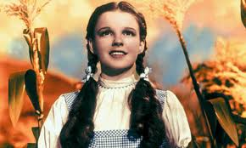

The Mother-Nurturing figure, Eve and Mary in Western Culture
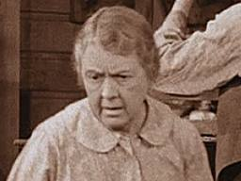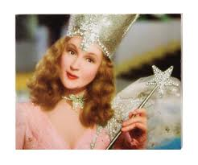

The Trickster-Hamper the hero’s progress, make trouble, may be a clown or magician
The Persona- The “wizard” is his public image, we find out at the end that he is just “an ordinary man”…..
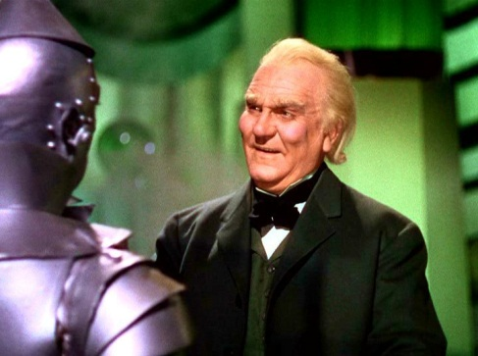
The Shadow-The dark side of the unconscious mind, usually comes across as the same sex as the dreamer.